9.Smulation and Performance Analysis of Big Data Processing for IoE Sensor Data using Hadoop and Apache Spark

Objective :
To simulate and compare Hadoop and Apache Spark for processing large-scale IoE sensor data by evaluating their processing speed and throughput.

Procedure :
Generate a large dataset containing IoE sensor readings such as temperature, humidity, and pressure.
Load the generated dataset into the Hadoop and Apache Spark environments.
Process the sensor data using Hadoop MapReduce and Spark processing techniques.
Measure the total processing time taken by both frameworks.
Calculate throughput based on the amount of data processed per second.
Compare the speed and throughput of Hadoop and Spark using tables and graphs.
Analyze the performance and identify the more efficient framework.

Program Code :
import matplotlib.pyplot as plt

# =====================================
# HADOOP vs APACHE SPARK COMPARISON
# =====================================

# Number of IoE sensor records
records = [100000, 500000, 1000000, 5000000, 10000000]

# Assumed execution time (seconds)
hadoop_time = [8, 25, 45, 180, 350]
spark_time = [5, 14, 25, 90, 170]

# =====================================
# PERFORMANCE CALCULATIONS
# =====================================

# Throughput = Records / Execution Time
hadoop_throughput = [
n / t for n, t in zip(records, hadoop_time)
]

spark_throughput = [
n / t for n, t in zip(records, spark_time)
]

# Speedup = Hadoop Time / Spark Time
speedup = [
h / s for h, s in zip(hadoop_time, spark_time)
]

# Improvement percentage
improvement = [
((h - s) / h) * 100
for h, s in zip(hadoop_time, spark_time)
]

# =====================================
# DISPLAY RESULTS
# =====================================

print("HADOOP MAPREDUCE vs APACHE SPARK")
print("-" * 85)
print("Records\t\tHadoop(s)\tSpark(s)\tHadoop TP\tSpark TP")
print("-" * 85)

for i in range(len(records)):
print(
f"{records[i]:,}\t"
f"{hadoop_time[i]}\t\t"
f"{spark_time[i]}\t\t"
f"{hadoop_throughput[i]:.2f}\t"
f"{spark_throughput[i]:.2f}"
)

print("\nSpeedup:", [round(x, 2) for x in speedup])
print("Improvement (%):", [round(x, 2) for x in improvement])

# =====================================
# GRAPH 1: EXECUTION TIME
# =====================================

plt.figure(figsize=(9, 5))

plt.plot(records, hadoop_time, marker='o',
linewidth=2, label='Hadoop MapReduce')

plt.plot(records, spark_time, marker='s',
linewidth=2, label='Apache Spark')

plt.xlabel("Number of IoE Sensor Records")
plt.ylabel("Execution Time (Seconds)")
plt.title("Execution Time Comparison")

plt.legend()
plt.grid(True)
plt.tight_layout()
plt.show()

# =====================================
# GRAPH 2: THROUGHPUT
# =====================================

plt.figure(figsize=(9, 5))

plt.plot(records, hadoop_throughput, marker='o',
linewidth=2, label='Hadoop MapReduce')

plt.plot(records, spark_throughput, marker='s',
linewidth=2, label='Apache Spark')

plt.xlabel("Number of IoE Sensor Records")
plt.ylabel("Throughput (Records/Second)")
plt.title("Throughput Comparison")

plt.legend()
plt.grid(True)
plt.tight_layout()
plt.show()
Output :
Table : SPEED ( Hadoop vs spark )
Records | Hadoop speed | Spark speed
100000 | 8 | 5
500000 | 25 | 14
1000000 | 45 | 25
5000000 | 180 | 90
10000000 | 350 | 170

Table : THROUGH PUT ( Hadoop vs spark )
Records | Hadoop speed | Spark speed
100000 | 12500.0 | 20000.00
500000 | 20000.0 | 35714.29
1000000 | 22222.22 | 40000.00
5000000 | 27777.78 | 55555.56
10000000 | 28571.43 | 58823.53

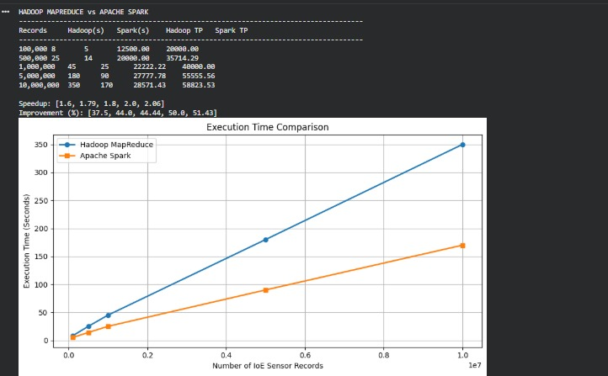

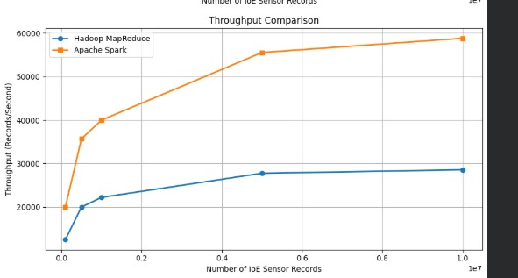

Result :
The simulation successfully compared Hadoop and Apache Spark for IoE sensor data processing. Apache Spark demonstrated faster processing speed and higher throughput than Hadoop due to its in-memory processing capability.

